Story 01 - Book Overview

## Description

As a user

I want to see the overview of books

So that I can see which books are in the library

## Wireframe

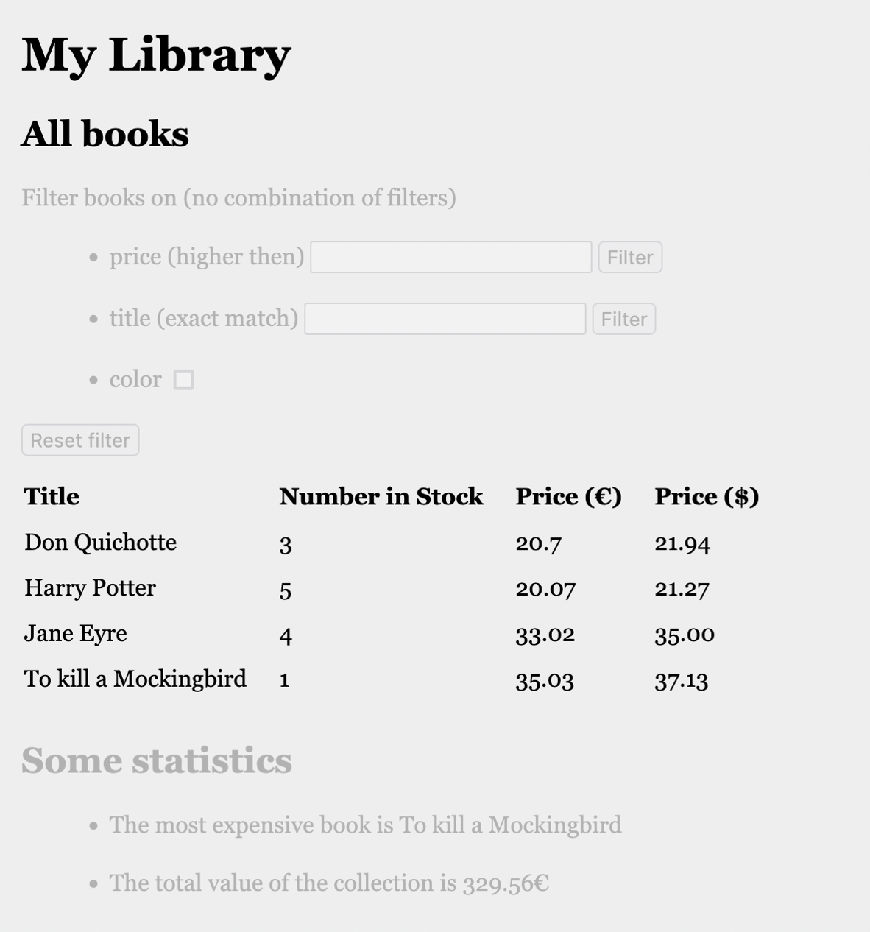

## Acceptance Criteria

* For each book, title, number in stock and price in euro and price in dollar are shown in table overview.

## Technical Requirements

* The books are fetched from back-end by <http://localhost:8080/api/book/all> .
* The response is a JSON array of books with fields “title” (String), “numberInStock” (int), “price” (double), “inColor” (Boolean), “priceInDollar” (double).
  + Hint: create for each required field in the response a so-called getter-method in the class Book. E.g. the method “getPriceInDollar()” causes the field “priceInDollar” to be created.
* Use the conversion ratio €1 = $1.06.
* In the given collection (library), the book title is unique.